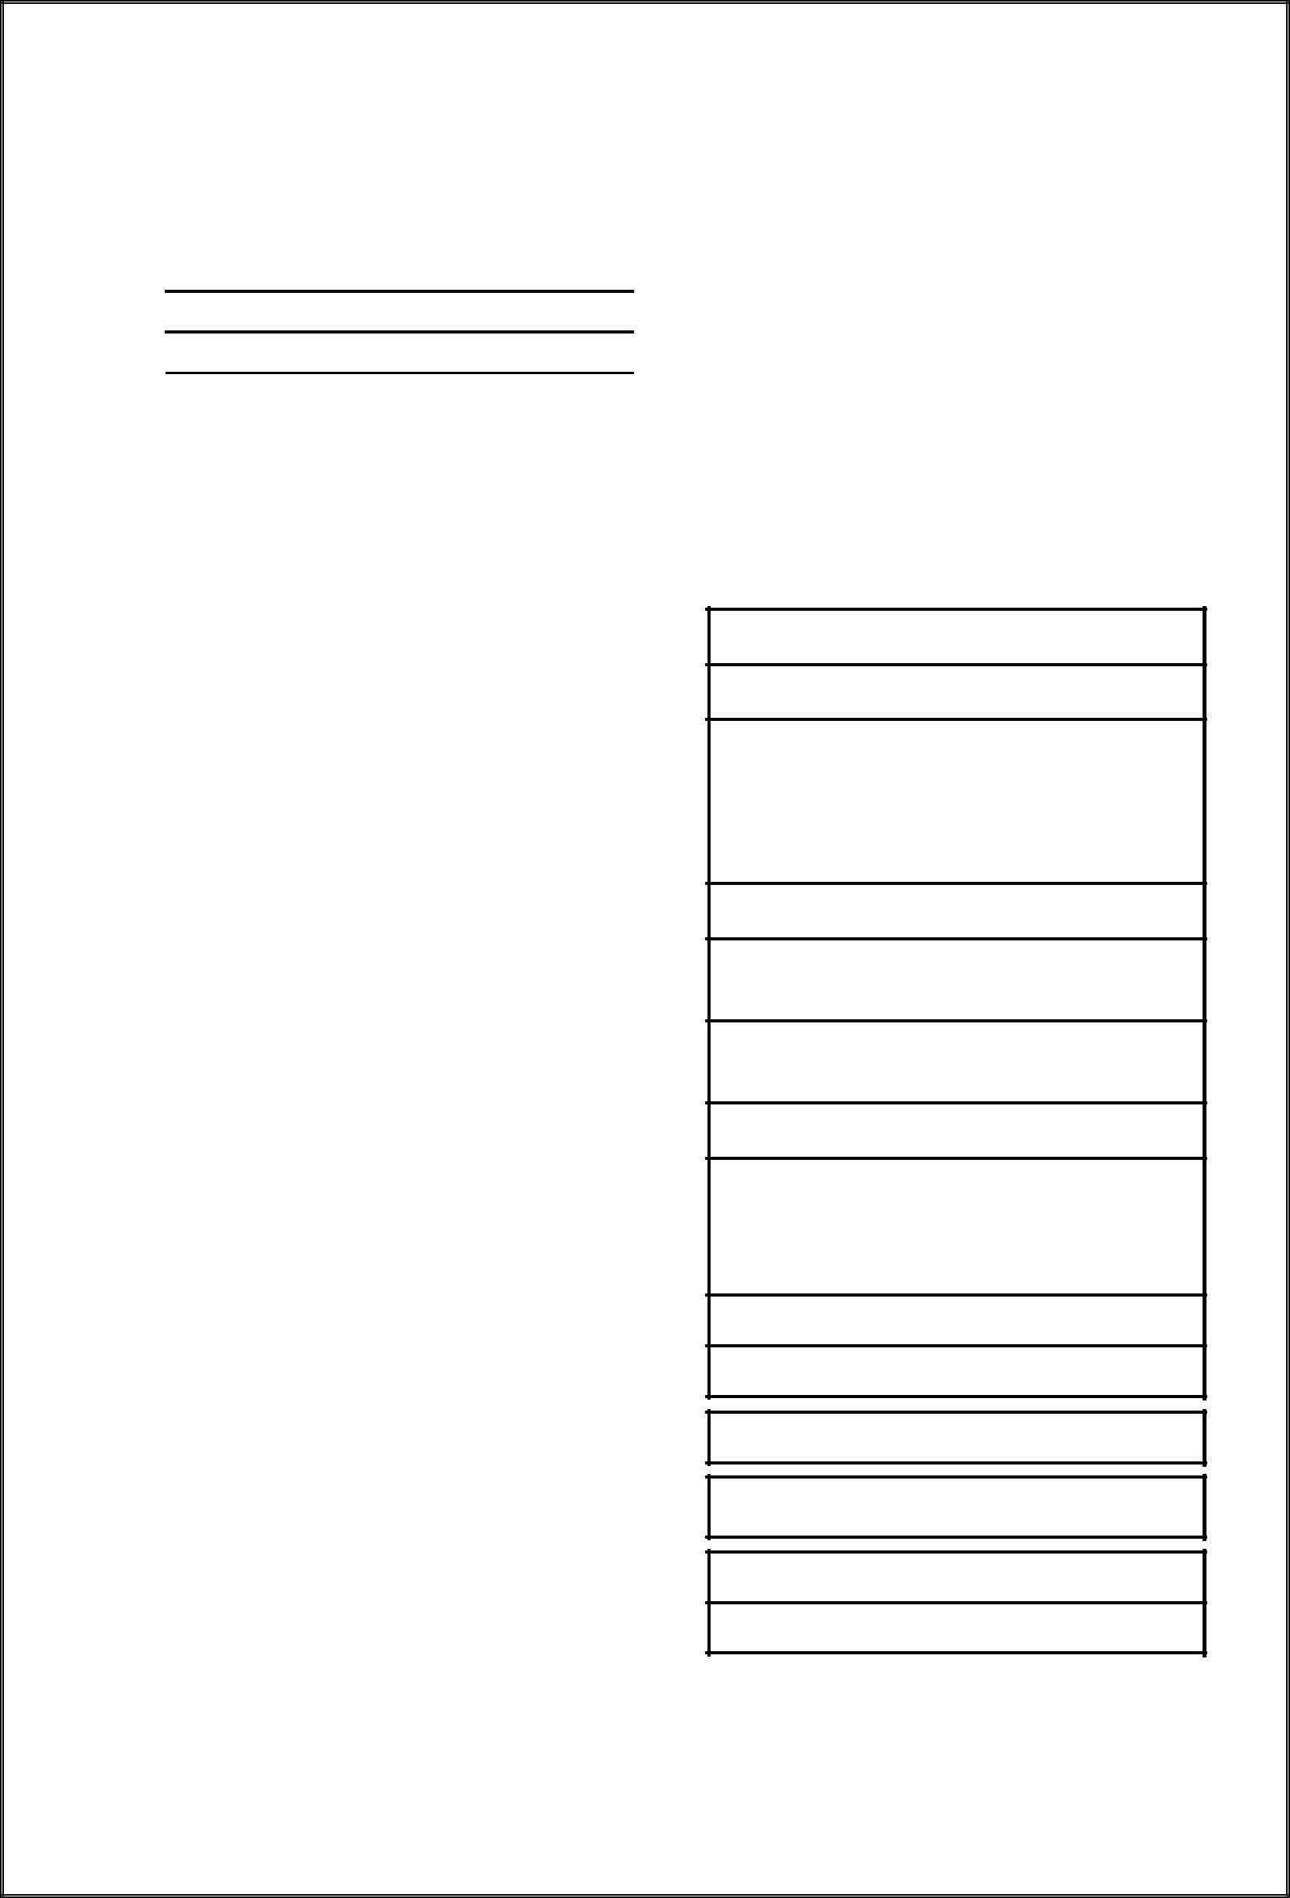**(Form – 401 is deleted by Notification No. STR-1506/CR-38/Taxation-1 Dt.08.09.2006)**

**FORM- 401**

(*See* rule 40(3))

***Application for allotment of sales Tax Deduction Account Number under sub-section***

***(8) of section 31 of the Maharashtra Value Added Tax Act, 2002***

To

Sir,

Whereas, I/We, the undersigned, is / are liable to deduct tax in accordance with sub-section (8) of section 31 of the Maharashtra Value Added Sales Tax Act, 2002 and whereas no tax deduction account number has been allotted to me/us. I/We hereby request that a sales tax deduction account number be allotted to me / us. I/We give below the necessary particulars.

* Category of Employer (who has awarded the contract)

(I) The Central Government and any State Government

1. An Industrial, Commercial or Trailing undertaking, Company or Corporation of the Central Government or of any State Government, whether set up under any law or not, and a Port Trust set up under the Major Ports Act, 1963.
2. A Company registered under the Companies Act, 1956
3. A Local authority, including Municipal Corporation, Municipal Council, Zilla Parishad, Contonment Board
4. A Co-operative Society registered under the Maharashtra Co-operative societies Acts, 1960
5. A registered dealer under the Maharashtra Value Added Tax Act, 2002
6. An Insurance or Financial Corporation or Company; and any Bank included in the Second Schedule to the Reserve Bank of India Act, 1934, and any Scheduled Bank recongnised by the Reserve Bank of India
7. Public Trust

*(*Please tick the appropriate box*)*

2. Name of the Employer

* Registration Certificate number under M.V.A.T Act, 2002 if any
* Address of the Employer

The above statements are true to best of my knowledge and belief.

- 1 -

Place

Date

**For Office use only**

Signature



Name and status of the applicant

Tax Deduction Account No. __________________________ Dated _____________ With effect from_________

Date Name and Designation of the Officer

**Acknowledgment**

Received an application in Form 401 for allotment of Tax Deduction Account Number under sub-section (8) of section 31 of the Maharashtra Value Added Sales Tax Act, 2002.

Serial .No.

Name of Employer

Address of the Employer

Tax Deduction Account No. _________________________ Dated _____________ With effect from_________

Date Name and Designation of the Officer

**Please use Tax Deduction Account No. in all the documents such as TDS certificate, returns, chalans and statements filed by you as required under the provisions of the Act.**

- 2 -